MULTI-LINGUAL SIGN LANGUAGE TO SPEECH
AND SPEECH TO SIGN TRANSLATOR

A Project Report
Submitted in the partial fulfillment of the requirements for the award of the degree of

Master of Computer Applications
In

Department of Computer Science and Applications
By

Uppalapati Naveen Varma

(2401600155)
Under the supervision of
Mrs. Swathi Voddi
Professor
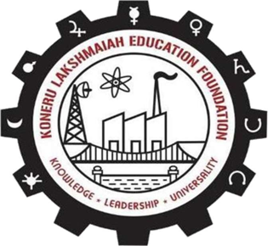

Department of Computer Science and Applications
K L E F, Green Fields,
Vaddeswaram, Guntur, Andhra Pradesh, India- 522502.
2025- 26

KONERU LAKSHMAIAH EDUCATION FOUNDATION

DEPARTMENT OF COMPUTER SCIENCE AND APPLICATIONS


DECLARATION

The Project Report entitled “MULTI-LINGUAL SIGN LANGUAGE TO SPEECH
AND SPEECH TO SIGN TRANSLATOR” is a record of bonafide work of Uppalapati Naveen Varma, submitted in partial fulfillment for the award of Master of Computer Applications in Computer Science and Applications of the K L University. The results embodied in this report have not been copied from any other departments/University/Institute.

Signature of the Student Uppalapati Naveen Varma (2401600155)

